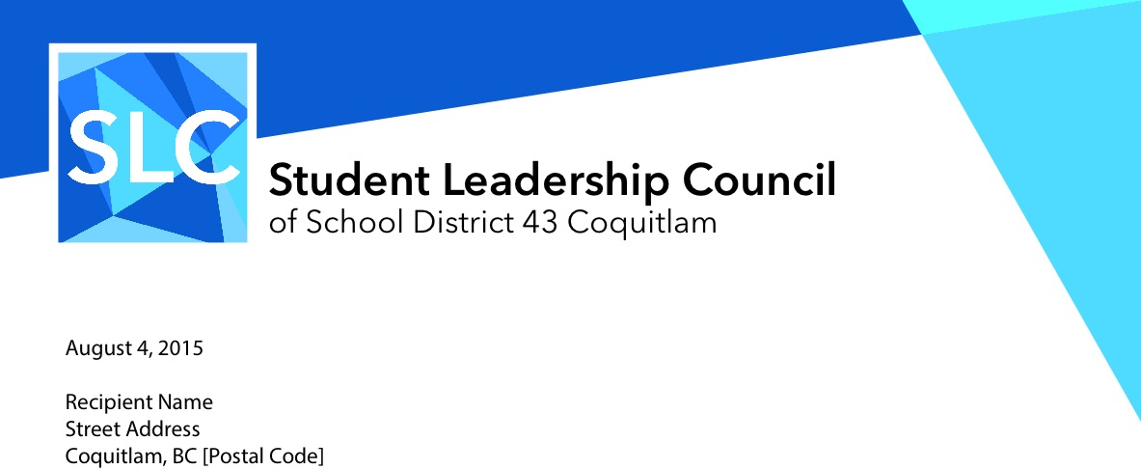

Dear parent/guardian of an SD43 student,

The Student Leadership Council (SLC) is an official partner group of School District 43 (Coquitlam). We strive to continually promote student voice within our District, and to offer opportunities for students to build their leadership skills. For more information about the council, visit [slcsd43.org](http://slcsd43.org)

Your child has been selected to attend our Showcase event to learn about student-led initiatives, at the Winslow Centre gymnasium, April 11th at 1PM. This activity will be supervised by school district staff.

By signing this form, you give permission for your child to attend this event on behalf of their school. You understand that your child will be missing one afternoon of regularly scheduled classes to attend this event, and that it is the responsibility of the student to make up missed work.

I, _____________________, give permission for my child, __________________, to attend this event of the Student Leadership Council of School District 43 (Coquitlam) on behalf of _____________________ School.

_____________________________ _______________________

SIGNATURE OF PARENT/LEGAL GUARDIAN DATE

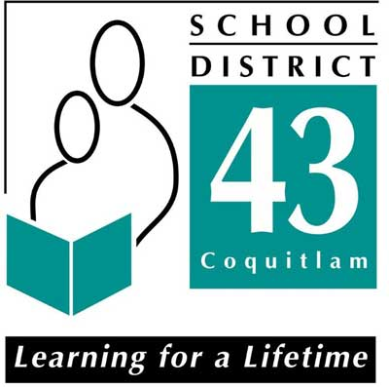

550 Poirier Street

Coquitlam, BC V3J 6A7



The Student Leadership Council and District 43 may use various media, website, and social media platforms for our event and share personally identifiable information for the purpose of celebrating student success and Student Leadership Council-based initiatives. Personally identifiable information may include their name and/or image. Note that these are online, publicly accessible services located outside of Canada. Due to the differences in information disclosure legislation between Canada and other jurisdictions, we are required by the provincial government to seek your consent prior to publishing any personally identifying information about your child to these services.

The Council and School District 43, as part of our event, will be taking photographs and/or video which may contain individual and/or groups of students. By signing this form, you are consenting to our use of your child’s name and images.

If you have any questions or concerns, please feel free to contact SLC by going to our website, [slcsd43.org](http://slcsd43.org)

___ **Yes** - I consent to the use of my child’s name and images, as outlined above.

___ **No**  - I do not consent to the use of my child’s name and images, as outlined above. Answering no to this will not preclude your child from participating in this event.

_____________________________ _______________________

SIGNATURE OF PARENT/LEGAL GUARDIAN DATE



550 Poirier Street

Coquitlam, BC V3J 6A7